The Right to Disability Accommodations in Court: A Review of Washington State Court Websites


Technical Report by the Northwest ADA Center

January 14, 2026

Dr. Heather Evans, Research Director
Kaitlin Spidell, Technical Assistance Specialist
Dr. Katie Warden, Director

Funding Statement
The research questions motivating this analysis were generated during conversations between the NW ADA Center and the Washington State Disability Justice Taskforce (DJT). The NW ADA Center staff provided the DJT informal guidance during Summer and Fall of 2023 and entered into a formal consulting contract with the Taskforce through the Washington State Administrative Office of the Courts (AOC) from December 16, 2023 through June 15, 2024, Interlocal Agreement number ICA24553. After completing the contract, the NW ADA Center staff elected to undertake a systematic review of WA State court websites. The NW ADA Center is funded by a grant from the National Institute on Disability, Independent Living, and Rehabilitation Research (NIDILRR grant number 90DPAD0002). NIDILRR is a Center within the Administration for Community Living (ACL), Department of Health and Human Services (HHS).

The contents of this technical report do not represent the policy of NIDILRR, ACL, HHS, and readers should not assume endorsement by the Federal Government nor by the State of Washington.

Acknowledgements
The research team at the NW ADA Center is grateful to colleagues and collaborators for their assistance in producing this report. We thank Dr. Karl Jones at the Administrative Office of the Courts’ Washington State Center for Court Research for providing a current list of municipal, district, and superior courts in the state. Thanks also to Linfield University undergraduate student Kayla Hudlock for the time she spent helping refine the coding protocol during her summer 2024 internship at the NW ADA Center. We are especially grateful to Disability Justice Taskforce co-chairs Supreme Court Justice Helene Whitener and King County Superior Court Judge David Whedbee for engaging the NW ADA Center in the planning stages of their taskforce and for the many informative and elucidative discussions regarding identifying and reducing barriers to Washington State courts. We deeply appreciate these and other colleagues’ efforts to ensure meaningful access to justice for individuals with disabilities.

Acronyms Used in the Report
ADA: Americans with Disabilities Act
AOC: Administrative Office of the Court
CART: Communication Access Realtime Translation
COP: Community of Practice
DJTF: Washington State Disability Justice Task Force
GR 33: Washington State Courts General Rule 33
PDF: Portable Document Format
WCAG: Web Content Accessibility Guidelines
WLAD: Washington Law Against Discrimination

Website Terms
Navigation Menu: A collection of links (usually in a bar or panel across the top, side, or bottom of a webpage) that lets users jump to different sections or pages of the site.
Sidebar Navigation: A vertical navigation menu usually located on the left (or sometimes right) side of a webpage.
Header Menu or Top Navigation: A horizontal menu across the top of the webpage.
Drop-down Menu: A nested list of items that appear when you hover over or click on a top-level menu item.
Link Tabs or Menu Items: The individual clickable items (like “Contact Us” or “ADA Policy”) within the navigation menu.

Executive Summary

This technical report evaluates the extent to which Washington State courts’ provide meaningful notice of the right to disability accommodation on their public facing websites, in alignment with aims of the Americans with Disabilities Act (ADA) and Washington State Courts General Rule 33 (GR 33). This study analyzed 171 municipal, district, and superior court websites, focusing on the presence of ADA-related content including contact information for disability access inquiries, instructions for requesting disability accommodation, description of appeal procedures, and accessible mechanisms for submitting requests (i.e., standardized forms related to accommodations.)

Key findings
- Only 36% of courts posted any ADA-related information on their websites; 64% had no information at all.
- Only 22% of court websites listed contact information for ADA inquiries and access questions.
- Superior courts were more likely to include ADA content on their websites (77%) compared to district (40%) and municipal (16%) court websites.
- Less than 2% of courts provided instructions on grievance procedures for appealing concerns related to an accommodation request.
- In general, having a clearly designated ADA or Access Coordinator significantly increased the likelihood of posting essential ADA information on a court website.
- Specifically, courts who listed an ADA Coordinator on their website were 32 times as likely to provide accommodation request instructions, 11.5 times as likely to post GR 33 information, and six times as likely to provide an accommodation request form on the website.

These findings indicate the majority of Washington State court websites fail to provide meaningful public notice of the right to request disability accommodations at court. Moreover, few Washington State court websites provide practical information about how to exercise this right, such as who to contact with disability access inquiries, who qualifies for accommodations, or how to request them. Accommodations are critical to ensuring disabled people’s access to state and local government services, including the court system. In order to access this fundamental right, disabled court users must have basic information about accommodations and the process for requesting them.

Recommendations
Including ADA information on court websites is a key strategy for providing disabled people with information about their rights. To do so, we recommend that court actors:
- Designate and publicize an ADA Coordinator for each court.
- Create a dedicated ADA accommodations webpage with clear, consistent, and descriptive labels.
- Include essential information such as definitions, eligibility, request instructions, forms, and appeal/grievance procedures.
- Ensure websites and forms meet WCAG 2.1 Level AA standards.
- Provide ongoing ADA training for all court staff and professionals.

The research team at the NW ADA Center also strongly recommends that Washington State courts collect information on ADA accommodation requests and denials in a consistent, ongoing basis and develop a database for this purpose, in alignment with GR 33.¹ Consistently documenting disability accommodation requests submitted to each court would enable state actors to 1) empirically gauge the level of demand for such accommodations, 2) plan for and implement capacity building, and 3) intermittently evaluate court compliance with state and federal laws.

To address ongoing training needs related to fulfilling responsibilities under the ADA and GR 33, we also recommend formally connecting individuals designated as the ADA or Access Coordinator for each court with each other through formal or informal means. One way to build such an infrastructure would be to create a Community of Practice (COP) among those designated as court ADA Coordinators that holds regular, virtual meetings. The COP structure would foster peer mentoring, making it easier to onboard new court ADA Coordinators and disseminate relevant information, tools, and resources among existing ones.

By implementing these recommendations, Washington State courts can better fulfill their obligations under the ADA and GR 33, reduce barriers to access, and promote equitable participation in judicial proceedings for people with disabilities.

Table of Contents
Funding Statement i
Acknowledgements i
Acronyms Used in the Report ii
Website Terms ii
Executive Summary iii
Key findings iii
Recommendations iv
Purpose 1
Background 1
Federal Legislation: the ADA 1
The ADA’s Application to State Courts – Tennessee v. Lane 3
Washington State: General Rule 33 4
The Current Study: One Aspect of Measuring Whether WA State Courts are Following GR 33 6
Data & Methods 6
Analysis 8
Interpreting Odds Ratios: 8
Findings 9
Discussion 14
Recommendations 16
Recommendations for the State 17
Recommendations for Courts 18
Specific Examples 21
Examples of Best Practices 22
Examples of Areas for Improvement 26
Study Limitations 32
References 33

List of Tables
Table 1. Prevalence of ADA Accommodations Information on WA State Court Websites 9
Table 2. Prevalence of WA State Court Websites Containing Key ADA Information 10
Table 3. Among WA Court Websites with an ADA or Access Coordinator Identified, Prevalence of ADA Accommodations Info on Websites 11
Table 4. Prevalence of ADA Accommodation Information on Websites of Courts with an ADA Coordinator Compared to Those Without 12
Table 5. Odds of ADA Accommodations Info on Court Website When ADA or Access Coordinator is Identified 13

List of Figures
Figure 1. Superior court homepage featuring a navigation bar with a clearly labeled "Americans with Disabilities Act (ADA)" menu item that links directly to accommodation information. 22
Figure 2. Superior court ADA information page organized with frequently asked questions displayed in dropdown menus and links to accommodation request forms and grievance procedures. 23
Figure 3. District court website offering ADA accommodation forms and information in both English and Spanish. 24
Figure 4. Superior court website providing detailed information about the accommodation process but lacking any reference to a grievance procedure. 25
Figure 5. Superior court homepage with a “Request for Reasonable Accommodations for Persons with Disabilities” hyperlink located under “Quick Links” at the bottom of the webpage. 26
Figure 6. Timed pop-up message appearing on a superior court website that states, “You are now leaving our website,” with a five-second countdown before redirecting users. 27
Figure 7. Municipal court website showing a “GR 33 Request for Accommodation” link listed under “Common Resources”. 28
Figure 8. Error page message reading “Sorry, this site/page is currently unavailable,” which appears when users click on the ADA accommodation link from a municipal court website. 29
Figure 9. District court website displaying a mission statement emphasizing “equal access to justice for all,” yet offering no ADA accommodation information or forms. 30
Figure 10. Municipal court website featuring bright yellow headers on a white background, reducing text readability and visual contrast. 31

Purpose
This technical report examines one aspect of Washington State’s efforts to ensure compliance with the Americans with Disabilities Act (ADA) and disabled people’s access to state courts: do Washington State court websites provide meaningful notice of the right to an accommodation and instructions as to how to access that right? Roughly 18 years after the Washington State Supreme Court adopted GR 33, a general administrative rule establishing procedures for requesting, processing, and providing disability accommodations at court, this study evaluates the degree to which Washington State courts post these procedures on their public facing websites. The study included four stages: 1) developing a coding protocol to assess the degree to which public users could easily find information on court websites on how to request disability accommodations, 2) identifying and collecting websites of all 178 Washington State municipal, district, and superior courts, 3) reviewing and coding each court website, and 4) analyzing quantitative and qualitative data generated from the coding process.
Findings reveal that the vast majority (roughly three-quarters) of Washington State court websites do not provide notice of the right to accommodation nor instructions on how to access that right. These preliminary results align with other studies documenting limited ADA implementation among state and local government entities. This study underscores a critical gap between well-established rights and practical implementation of those rights in providing access to justice for people with disabilities.

Background

Federal Legislation: the ADA
Heralded as a transformative civil rights law for disabled people, the ADA prohibits disability-based discrimination in broad swaths of social life: employment, public accommodations, transportation, and state and local government services. The ADA provides the “negative” right to be free from discrimination, such as outright exclusion or unnecessary segregation based on disability. It also mandates “positive” rights, such as reasonable modifications, effective communication, and program access, all of which allow disabled people access to goods, services, and information. The provision of these “positive” rights is one of the ADA’s key legal requirements and vital to providing equal opportunity and access to disabled people. Within the ADA’s legal framework, the failure to provide any of these “positive rights” is considered an act of discrimination. In this report, we refer collectively to these “positive rights” as accommodations.
In addition to prohibiting disability-based discrimination and mandating the provision of accommodations, the ADA also includes procedural requirements. For example, the ADA requires all state and local government entities to publish public notice of basic ADA information as well as how the ADA applies to its programs and services (28 C.F.R § 35.106). To encourage compliance, the Department of Justice (DOJ) has published informal guidance, including a sample notice, to help state and local governments meet the ADA’s notice requirement (see ADA Best Practices Tool Kit for State and Local Governments). Per the DOJ guidance:
The notice should not be overwhelming. An effective notice states the basics of what the ADA requires of the state or local government without being too lengthy, legalistic, or complicated. It should include the name and contact information of the ADA coordinator (Id.).
The ADA does not explicitly require that notice be posted on an entity's website. However, the DOJ recommends that entities publish the ADA notice on their websites, which must be accessible (Id.).
In 2024, the DOJ published a final rule requiring that state and local government web content meet basic accessibility requirements. The DOJ explained the necessity for the new rule by pointing to the frequency with which state entities use the web to offer services, programs or activities to the public. Per the DOJ, state and local government agencies use the web to “disseminate information quickly and effectively” (Id. at page 20). The DOJ also highlighted how accessing information online may be done independently and quickly:
Websites ... allow members of the public to get information or request a service within just a few minutes, and often to do so independently. Getting the same information or requesting the same service using a staffed telephone line takes more steps and may result in wait times or difficulty getting the information. For example, state and local government entities’ websites may allow members of the public to quickly review large quantities of information, like information about how to register for government services, information on pending government ordinances, or instructions about how to apply for a government benefit. Members of the public can then use government websites to promptly act on that information by, for example, registering for programs or activities, submitting comments on pending government ordinances, or filling out an application for a government benefit. A member of the public could not realistically accomplish these tasks efficiently over the phone (Id. at pages 14-15).
Although the ADA does not contain a specific requirement that notice of rights be provided on state and local government entities’ websites, doing so may still be necessary under the ADA: information about the ADA's protections must be provided in whatever manner is “necessary to apprise” people of their rights.

The ADA’s Application to State Courts – Tennessee v. Lane
The United States Supreme Court affirmed the critical importance of the ADA in providing disabled people access to state and local court systems in Tennessee v. Lane (541 U.S. 509 (2004)), a case in which two wheelchair users argued that they were excluded from various Tennessee county courts. Both plaintiffs argued that inaccessible courthouses and the failure to make accommodations, such as moving a hearing from the second to first story in a courthouse without an elevator, excluded them from the judicial process. The key legal issue at stake in the case revolved around the constitutionality of the ADA’s application to state and local courts and whether individuals like the plaintiffs should be allowed to bring ADA lawsuits against a state.
In deciding the case, the Supreme Court noted that the plaintiffs’ experiences of exclusion were not uncommon. The ADA’s legislative history (including congressional findings which led to and supported the passage of the ADA) documented the widespread inaccessibility of court systems, the exclusion of disabled people from judicial processes, and the failure to provide accommodations such as interpretation services necessary to access court. Given both this history of exclusion and the fundamental nature of the right of access to the courts, the Supreme Court ruled that the ADA’s substantive requirements did indeed apply to state and local courts. Furthermore, the Court affirmed the “reasonableness” and necessity of the ADA’s “reasonable modification” or accommodation requirement, stating: the “affirmative obligation to accommodate persons with disabilities in the administration of justice... is, rather, a reasonable prophylactic measure, reasonably targeted to a legitimate end” (541 U.S. 509, 533 (2004).

Washington State: General Rule 33
Tennessee v. Lane brought national attention to the issue of courthouse accessibility. In its aftermath, various federal agencies, legal organizations, and state governments issued reports on and created resources to support disabled people’s access to the court system. In Washington, this work involved the creation of a committee, the adoption of a General Administrative Rule, the publication of sample forms, and an accommodation guidebook for courts.
In 2006, the Washington State Access to Justice Board’s Impediments Committee published a guide titled, “Ensuring Equal Access for People with Disabilities: A Guide for Washington Courts.” The 78-page guide outlines the legal basis for providing accommodations in court and includes examples of accommodations, common barriers experienced by disabled court users, sample jury instructions, and an extensive resource list. The preface to the guide includes a quote from Tennessee v. Lane and a simple call to action: “Washington courthouses and court services must be accessible to persons with disabilities. This Guide is intended to help” (iii).
In 2007, the Washington State Supreme Court adopted General Rule 33. The explicit purpose of GR 33 was to increase disabled individual’s access to Washington State courts by establishing a uniform procedure for requesting and granting accommodations. In large part, GR 33 requirements mirror those of the ADA; the Rule implements the ADA’s substantive requirements by identifying who is responsible for processing accommodation requests, by outlining the steps in that process, and by creating and mandating the use of two forms to request accommodations. In addition, GR 33 was intended to facilitate the creation of a statewide “comprehensive access management system” for processing accommodation requests.
To create a uniform statewide process, GR 33 mandates specific steps that should be taken to request and evaluate court accommodations. Per GR 33, an accommodation request should be made orally or in-writing, using a form approved by the Administrative Office of the Courts (AOC) and submitted to the presiding judge, an officer of the court, or appropriate designee. The accommodation request should include a description of the accommodation and the disability-related need. If appropriate, the court may request additional information about the applicant’s disability. In addition, GR 33 notes that medical and health information should be submitted using a separate form created by the AOC called “Sealed Medical and Health Information,” stipulating that medical information would only be available to the court and the person requesting the accommodation.
Next, GR 33 outlined the factors the court should consider in deciding whether to grant the requested accommodation. These factors mostly mirror the substantive requirements of the ADA. For example, the court should give primary consideration to the accommodation requested by the applicant, and accommodation requests should be evaluated on a case-by-case basis that takes into account the nature of the applicant’s disability and the feasibility of the particular accommodation. Similarly, accommodation requests can be denied if the accommodation would create an undue burden, fundamentally alter the nature of the court service, or create a direct threat to the safety of the applicant or others. Determining whether an accommodation poses an undue burden or fundamental alteration must be based on consideration of all resources available for funding the service or activity. GR 33 also provides guidance specific to the court setting. Per GR 33, a court may deny a request made without sufficient notice if delaying the proceeding to arrange for accommodations would cause significant prejudice to another party. Finally, the denial of an accommodation must be in writing and include the reasons for the denial.

The Current Study: One Aspect of Measuring Whether WA State Courts are Following GR 33
Recognizing the disparities experienced by disabled court users, the Washington State Supreme Court created a “Disability Justice Taskforce” in 2022 to identify and address barriers to access within Washington courts. One initial focus of the Taskforce was evaluating the implementation of GR 33. The Taskforce Steering Committee reached out to the Northwest ADA Center, part of a network of federally funded regional centers promoting voluntary compliance with the ADA (ADA National Network). The analysis presented here arose out of conversations between co-chairs of the Taskforce and the Northwest ADA Center’s research team. After completing the consulting contract with the Taskforce, the Northwest ADA Center decided to undertake an empirical examination of a single aspect of court compliance: providing notice of and instructions on obtaining the right to accommodation on court websites. In proposing GR 33, the Washington State Access to Justice Board and the Washington State Bar Association affirmed that an efficient accommodation process must start with public notice: “The first step requires an effective process for individuals to be able to notify the court of a need for an accommodation and the nature of the accommodation requested.” As courts provide more information about their services online and as the public turns even more to the internet for resource gathering, providing this notice online is critical. Therefore, in this study, we ask: Do Washington State court websites include information that would adequately allow “individuals to be able to notify the court of a need for an accommodation and the nature of the accommodation request?”

Data & Methods
With the assistance of the Washington State AOC, the research team acquired a list of all 178 trial courts serving 39 counties in Washington, including superior, district, and municipal level courts. Appellate courts were not included in this analysis. Seven municipal courts were excluded from the list as they are smaller counties that share a single court or have closed and refer users to neighboring court websites. After these exclusions, a total of 171 individual court websites were analyzed. Court websites were reviewed for the presence (or absence) of key information that included: 1) general information regarding disability related accommodations, 2) a definition of disability accommodations, and 3) contact information for learning more about disability accommodations. In addition, our team assessed the relative ease of accessing other information pivotal to the accommodations process such as explicit step-by-step instructions on how to request accommodation, how to appeal a denial, how to file a grievance, and the ease of methods for submitting accommodation requests or other documentation.
To evaluate these elements, the research team developed a court website coding protocol based on the ADA’s substantive notice requirements, GR 33’s requirements, and the DOJ’s informal guidance on providing effective notice. The coding protocol was refined through an iterative process of group coding a sample of websites, dividing websites among three coders, cross checking results for inter-coder reliability, and adjusting the coding scheme for clarity and specificity. As part of the iterative process, the majority (65%) of court websites were reviewed and coded at least twice to verify consistency. Once the protocol was finalized, one member of the coding team reviewed all 171 court websites afresh, recording salient accommodation related information present as of February through May 2025.
It is important to note that this assessment did not focus on whether court websites were in compliance with digital accessibility standards set by the DOJ which will require state agencies of all sizes to comply with WCAG 2.1, Level AA standards in April 2027. In response to efforts by the state’s Disability Justice Taskforce, as well as in anticipation of upcoming digital accessibility requirements, some courts are actively working to update and improve the overall accessibility of their facilities, including websites. The research team has verified that at least a handful of court websites have been modified since we conducted the coding project. Thus, the data presented here represent a snapshot in time (February-May 2025) and document the presence of select information regarding disability accommodations available on Washington State court websites.

Analysis
Data collected from reviewing and coding court websites were uploaded into and analyzed using statistical analysis software SPSS v31. Descriptive statistics and comparative summaries are presented in the findings section below. To test for statistical correlation or meaningful association between variables, we calculated odds ratios. Because these data include the population rather than a sample of Washington State court websites, the descriptive statistics presented here are not subject to inference. Nonetheless, for each odd ratio we include a 95% confidence interval to indicate statistical significance of the test for association.

Interpreting Odds Ratios:
The odds ratio (OR) is a measure of how strongly an “event” is associated with “exposure.” The odds ratio is a ratio of two sets of odds: the odds of the event occurring in an exposed group versus the odds of the event occurring in a non-exposed group. In this case, the event of interest is having ADA information posted on a court website; the exposure of interest is having a clearly designated contact person in the role of ADA or Access Coordinator indicated on the court website. A breakdown of how elements are defined and ratios are calculated is listed below:
Element definitions:
- Exposed group: website with ADA or Access Coordinator listed
- Non exposed group: website with no ADA or Access Coordinator listed
- Event: presence of ADA info
- Non event: absence of ADA info
Odds ratio: odds of exposed group / odds of non exposed group
- a = odds for websites with ADA or Access Coordinators = (Info presence / info absence)
- b = odds for websites with no ADA or Access Coordinators = (Info presence / info absence)
- Odds Ratio = a/b
The odds ratio helps identify how likely an exposure is to lead to a specific event. The larger the odds ratio, the higher odds that the event will occur with exposure. An odds ratio less than one (OR<1) implies the event has lower odds of happening with the exposure. An odds ratio helps answer the question: does having a clearly designated ADA or Access Coordinator increase the odds that a court website will include relevant information about accommodations?

Findings

Analysis indicates that roughly one-third (36%) of Washington State court websites contain any information at all about the ADA or disabled court users’ right to request an accommodation. Just over one-quarter (27%) of court websites include ADA information on the court homepage. This means that the majority (64%) of courts post nothing about the ADA or accommodations on their websites. Overall, a larger proportion of superior court websites contain ADA information than other court websites (77% compared to only 40% of district and 16% of municipal court websites). See Table 1 for a breakout of whether and where ADA information was posted online by type of court.

Table 1. Prevalence of ADA Accommodations Information on WA State Court Websites
 | Municipal | District | Superior | All Courts (Combined)
ADA info posted on Homepage | 8.3% | 29.2% | 64.1% | 26.9%
ADA info posted somewhere other than Homepage | 7.8% | 14.7% | 35.7% | 12.8%
Any ADA info posted anywhere | 15.5% | 39.6% | 76.9% | 36.3%
No ADA info posted | 84.5% | 60.4% | 23.1% | 63.7%
N (number of court websites) | 84 | 48 | 39 | 171
Source: Authors’ analysis of WA State court websites, Feb-May 2025.

A more fine-grained analysis reveals other concerning trends. For example, the overwhelming majority of court websites do not indicate how to contact the court for ADA inquiries (only 22% of courts listed contact information for access questions). In addition, rarely is a designated ADA Coordinator listed; only 9% of all court websites listed an individual in this role. Table 2 shows the proportion of court websites that post these key pieces of ADA-related information, those that post GR 33, provide explanations and instructions on the accommodation process, and those that include standardized forms court users can complete and submit. One-fifth of court websites post instructions on how to request disability accommodation directly on the website, without needing to access other sites or download files. Only 10% of websites post a link to GR 33.
A larger proportion of superior court websites post instructions (48%), define what a ‘reasonable accommodation’ is (41%), and post GR 33 (33%). Just over one-half (56%) of superior court websites provide an accommodation request form for users to complete and submit, compared to 33% of district courts and 12% of municipal courts. Only 7% of court websites provide a form that court users can use to appeal a denial or file a grievance related to accommodations; however, less than 2% include explicit instructions on the appeal or grievance process.

Table 2. Prevalence of WA State Court Websites Containing Key ADA Information
 | Municipal  (N=84) | District  (N=48) | Superior (N=39) | All Courts Combined  (N=171)
ADA Access Point of Contact
Access inquiry (including ADA Coordinators when listed) contact info provided (e.g., phone number, email, mailing address) | 6.0% | 29.2% | 48.7% | 22.2%
ADA or Access Coordinator identified on court website | 1.2% | 12.5% | 20.5% | 8.8%
Explanation of & Instructions on Accommodations Process
GR 33 clearly posted | 2.4% | 6.3% | 33.3% | 10.5%
Accommodation is defined | 3.6% | 14.6% | 41.0% | 15.2%
Accommodation request instructions posted on website (without needing to download additional files)* | 6.0% | 25.0% | 48.7% | 21.1%
Appeal instructions posted (e.g., process to counter an accommodation request denial) | 0.0% | 0.0% | 7.7% | 1.8%
Standardized Forms
Accommodation request form provided | 11.9% | 33.3% | 56.4% | 28.1%
Sealed medical health form provided | 7.1% | 25.0% | 38.5% | 19.3%
Appeal/grievance form provided | 1.2% | 12.5% | 12.8% | 7.0%
Users referred to WA Administrative Office of the Courts generic template form(s) | 2.4% | 2.1% | 7.7% | 3.5%
Source: Authors’ analysis of WA State court websites, Feb-May 2025.
*Note: 5 courts (1 Municipal, 2 District and 2 Superior) or 3% of all court websites indicated only that users should "contact the court" for information regarding and/or instructions for requesting an accommodation.

Next, we examine the prevalence of ADA information posted on the small number of court websites that indicate having a designated ADA Coordinator. Table 3 shows the prevalence of ADA accommodation information posted on the 15 websites in which the court lists a contact person for access inquiries. The large majority (80%) of those websites provide instructions on how to request disability accommodation and 67% provide a standardized form for doing so, but only one-third of those (33%) explain what disability accommodation is or provide examples of accommodation. Roughly one-half (47%) of the courts listing an ADA Coordinator also post GR 33 on their site. However, none of the 15 court websites contain instructions on or forms for appealing an accommodation request denial or filing a grievance.

Table 3. Among WA Court Websites with an ADA or Access Coordinator Identified, Prevalence of ADA Accommodations Info on Websites
 | Municipal (N=1) | District (N=6) | Superior (N=8) | All Courts Combined (N=15)
ADA Access Point of Contact
Any ADA or Access Coordinator identified on court website | 100.0% | 100.0% | 100.0% | 100.0%
ADA Coordinator or access inquiry contact info provided (e.g., phone number, email, mailing address) | 100.0% | 100.0% | 100.0% | 100.0%
Explanation of and Instructions on Accommodations Process
GR 33 clearly posted | 0.0% | 33.3% | 62.5% | 46.7%
Accommodation is defined | 0.0% | 16.7% | 50.0% | 33.3%
Accommodation request instructions posted on website (without needing to download additional files)* | 100.0% | 50.0% | 100.0% | 80.0%
Appeal denial instructions posted | 0.0% | 0.0% | 0.0% | 0.0%
Standardized Forms
Accommodation request form provided | 100.0% | 50.0% | 75.0% | 66.7%
Sealed med health form provided | 100.0% | 33.3% | 75.0% | 60.0%
Appeal/grievance form provided | 0.0% | 0.0% | 0.0% | 0.0%
Users referred to AOC generic template form(s) | 100.0% | 100.0% | 100.0% | 100.0%
Source: Authors’ analysis of WA State court websites, Feb-May 2025.
Note: *1 of the 15 court (1 district court) websites indicated only that users should "contact the court" for information or instructions for requesting accommodation.

The information presented in Table 3 demonstrates that having a designated contact for ADA inquiries does not necessarily guarantee that best practices are followed regarding providing clear definitions, examples, and instructions on requesting accommodation, nor on the process for appealing denials or filing ADA related grievances. Likewise, not listing a designated ADA Coordinator does not equate to lacking all required information. Table 4 presents a breakdown of the presence or absence of accommodations information by courts with an ADA Coordinator listed compared to those without. Among court websites listing an ADA Coordinator, 14% of those sites do not post instructions on how to request accommodations, whereas 84% of courts without an ADA Coordinator lack accommodation request instructions. One-third of websites listing an ADA Coordinator do provide a request form; however nearly one-quarter of websites without an ADA Coordinator do post an accommodation request form.

Table 4. Prevalence of ADA Accommodation Information on Websites of Courts with an ADA Coordinator Compared to Those Without
 | No ADA or Access Coordinator  # (%) | ADA or Access Coordinator  # (%) | Total  # (%)
Accommodation request instructions on website without downloading file*
No | 128  (84%) | 2  (14%) | 130  (78%)
Yes | 24  (16%) | 12  (86%) | 36  (22%)
Accommodation request form provided
No | 118  (76%) | 5  (33%) | 123  (72%)
Yes | 38  (24%) | 10  (67%) | 48  (28%)
GR 33 Posted
No | 145  (93%) | 8  (53%) | 153  (89%)
Yes | 11  (7%) | 7  (47%) | 18  (11%)
Total | 156  (91%) | 15  (9%) | 171  (100%)
Source: Authors’ analysis of WA State court websites, Feb-May 2025.
Note: * Five court websites whose only instructions on how to request an accommodation is to "contact the court" are dropped from the calculation of ‘Accommodation request instructions on website without downloading file’.

The percentages presented in Tables 3 and 4 show sizable differences in the presence and amount of accommodation information listed on websites of courts with a designated ADA Coordinator versus those courts without an ADA Coordinator. However, simply comparing percentages do not inform us as to whether these differences are happenstance or form a consistent pattern. Another way to examine the relationship between these variables is to calculate the odds of accommodation information appearing on a court website that includes an ADA Coordinator compared to the odds of this information appearing on a court website when an ADA Coordinator is not listed (i.e., calculating an odds ratio.)
Statistical analysis shows that having a designated contact for ADA inquiries listed increases the likelihood of a court website providing three key pieces of information critical to court users with disabilities: instructions on how to request an accommodation; a form (i.e., streamlined mechanism) for submitting an accommodation request; and information about GR 33 (see Table 5.) A court website listing an ADA Coordinator is very likely to post - specifically, has 6 to 1 odds of posting - instructions on requesting accommodations; and the odds of providing a form to do so is 2 to 1 (or twice as likely). In contrast, courts that don’t identify an ADA or Access Coordinator have significantly lower odds (0.19 to 1 and 0.32 to 1) of posting this information on their websites.
Notably, there is less than a 1 to 1 odds of websites posting GR 33 information regardless of whether an ADA Coordinator is listed (the odds with an ADA Coordinator is 0.88 to 1 and 0.08 to 1 without an ADA Coordinator.) Nonetheless, court websites indicating an ADA Coordinator have larger odds of doing so than those without an ADA Coordinator (0.88>0.08).

Table 5. Odds of ADA Accommodations Info on Court Website When ADA or Access Coordinator is Identified
 | Instructions on Requesting Accommodation Posted | Accommodation Request Form Provided | GR 33 Information Posted
ADA or Access Coordinator ª
Presence | 12 | 10 | 7
Absence | 2 | 5 | 8
Odds | 6 | 2 | 0.88
No ADA or Access Coordinator ^{b}
Presence | 24 | 38 | 11
Absence | 128 | 118 | 145
Odds | 0.19 | 0.32 | 0.08
Odds (a/b) | (6 / 0.19) | (2 / 0.32) | (0.88 / 0.08)
Odds Ratio | 32 | 6.21 | 11.53
Confidence Intervals | [6.7 , 152.1] | [1.9 , 19.3] | [3.5 , 37.7]
Source: Authors’ analysis of WA State Court websites, Feb-May 2025.
Note: 5 court websites whose only instructions on how to request an accommodation is to "contact the court" are not included in this analysis.

More telling is to compare the odds, i.e., calculate the odds ratio of these key pieces of information being present when an ADA Coordinator is identified on the court website. A court website that lists an ADA or Access Coordinator is 32 times as likely to have accommodation instructions posted on the website than a court that does not list a designated ADA Coordinator. A court website that lists an Access Coordinator is just over 6 times as likely to provide an accommodation request form as those without coordinators. Despite how infrequently GR 33 is posted on court websites, the presence of an ADA Coordinator makes it 11.5 times as likely for it to be included than websites with no Access Coordinator listed. These odds ratios and respective confidence intervals show a statistically significant association between having an ADA or Access Coordinator and the likelihood of at least the minimum information regarding how to make an accommodation request being posted on the court website.

Discussion
The findings of this study reveal a significant gap between the ADA’s legal requirements, the procedural processes outlined in GR 33, and the information available on most Washington State court websites. Nearly two decades have passed since the adoption of GR 33, and the ADA recently celebrated its 35th anniversary. A wealth of publicly available resources, including sample forms and notices, have been developed to help courts improve accessibility. Yet, the majority of Washington State court websites do not provide even a basic notice of the right to disability accommodations or explain the steps required to request them.
These results are significant given the ADA’s explicit requirements that state and local governments, including courts, provide public notice of the ADA’s provisions. Although the ADA does not specifically mandate that notice be published online, DOJ guidance makes clear that posting ADA information on an entity’s website is considered a best practice. The DOJ’s new rule on web accessibility acknowledges the vital importance of state and local government agency websites, noting that these websites provide the public with information about services and programs which can be reviewed independently and quickly. Thus, even without an explicit legal mandate, posting ADA information online is necessary to effectively apprise court users of their rights.
Our study highlights the absence of three key pieces of ADA information on state court websites: an ADA point of contact, explanation of and instructions on the accommodation process, and standardized forms. The presence of this ADA information varied across court types; 85% of municipal court websites contained no ADA-related information. In contrast, 76% of superior court websites contained at least some ADA information. However, even among superior court websites, a majority did not include information about GR 33 or explain how to request an accommodation. As a group, 64% of state court websites contained no information about the ADA at all. This overwhelming lack of ADA notice is a stark omission. Without such notice, disabled court users may not be aware of the right to request an accommodation.
Roughly one-fifth of court websites included contact information for ADA-related inquiries (22%) and instructions for requesting an accommodation (21%). Only 11% of websites included information about or a link to GR 33, which, although not written in plain language, outlines the right to and general process for requesting an accommodation in Washington State courts. Critically, less than 2% of court websites included any information about what to do if an accommodation is denied. Taken together, these missing pieces of information cover the entire accommodation process: information about who to contact to ask questions, how to start the accommodation process, the general steps in the process, and what to do if access has not been provided.
The majority of state court websites do not include the standardized forms that were developed alongside GR 33. Less than 30% of court websites include a standardized accommodation request form, and just under 20% include a standardized sealed medical and health information form. Sample forms are available online and can be downloaded as word documents that individual courts may tailor (e.g., by including the contact information for the court’s ADA Coordinator or the county and court name). Using these standardized forms would both assist disabled court users in making accommodation requests and contribute to one of GR 33’s original purposes: “to accelerate the development of a comprehensive access management system to assure a clear, consistent, and effective approach to providing appropriate accommodations in Washington courts.”
Analysis of our findings demonstrates that having a clearly identified ADA or Access Coordinator strongly increases the likelihood that essential accommodation information is available online. Courts listing a Coordinator were 32 times as likely to provide instructions for requesting accommodation, 11.5 times as likely to post GR 33 notice, and six times as likely to include an accommodation request form. This indicates that institutional accountability and designated personnel are critical to promote compliance with the ADA and GR 33. However, even among courts with an ADA Coordinator, information about appeal or grievance procedures remains scarce, suggesting that simply having a coordinator may be insufficient without broader institutional commitment and standards.
These results highlight the importance of the “first step” in equitable access: providing public notice. Despite a clear mandate and a wealth of existing resources, examples, and standardized templates provided, most Washington State court websites fail to provide meaningful notice of the right to a disability accommodation. A court website’s lack of clear definitions, instructions, and contact information regarding accommodation significantly limits the ability of individuals with disabilities to exercise their legal rights. Court users may be able to obtain this information by phone or in person; however, doing so still requires them to already know that they have a right to request an accommodation.
Although this study did not evaluate court websites’ compliance with technical digital accessibility standards, a recent report authored by the Washington State Supreme Court Disability Justice Taskforce points to an audit of a sample of court websites that indicate this is also an area in need of remediation for many state courts. Overall, our study suggests that improving ADA compliance in Washington State requires multiple approaches including utilizing the resources created alongside GR 33, designating and supporting ADA Coordinators, updating court websites with standardized content, and ensuring accessibility of webpages and forms. Addressing these gaps is essential for ensuring meaningful access to justice for individuals with disabilities.

Recommendations
Our study focused on one aspect of the ADA’s overarching non-discrimination requirements: whether public notice of ADA rights was provided on state court websites. However, public notice is just the first step to creating access for disabled court users. In this section, we provide recommendations related to the gaps we identified as well as recommendations to support courts in implementing broader ADA requirements. For example, we strongly recommend that regular and ongoing training be provided to court employees on general ADA requirements as well as individual court practices. We start by acknowledging that many excellent resources are already available, such as the standardized court forms for requesting accommodations and sealing medical information. The Washington State Access to Justice Board’s Impediments Committee developed a comprehensive resource in 2006 and revised in 2011 titled “Ensuring Equal Access for People with Disabilities: A Guide for Washington Courts.” The guide was created to help court staff ensure that individuals with disabilities have meaningful access to court proceedings. The guide includes appendices containing sample policies, notices, and even jury instructions. Many of our recommendations below echo the principles and best practices outlined in that guide.

Recommendations for the State
One vital component currently missing for assessing the degree of compliance with GR 33 is a consistent statewide mechanism for documenting and tracking accommodation requests in court proceedings. The research team at the NW ADA Center strongly recommends that Washington State courts collect this information in a consistent, ongoing basis and develop a database for this purpose, ideally maintained by the Administrative Office of the Courts (AOC). Consistently documenting disability accommodation requests submitted to each court would enable analysts to 1) empirically gauge the level of demand for such accommodations, 2) plan for and implement capacity building, and 3) intermittently evaluate court compliance with state and federal laws.
Documenting when, where, and what types of disability accommodations are requested would provide critical information for assessing court users’ needs both statewide and regionally. Documenting accommodations requests at multiple stages - starting from the initial inquiry to the approval, denial or appeal process - would enable the AOC to also evaluate which types of accommodations are most frequently denied, potentially pointing to needed areas of targeted education for court staff, judges, and/or court users. In addition, these data would allow calculation of the average length of time to provide certain types of accommodations so that resources could be efficiently allocated (for example, identifying a need to contract with more American Sign Language interpreters in a specific region.)
To address ongoing training needs related to fulfilling responsibilities under the ADA and GR 33, we also recommend that infrastructure is developed to put individuals designated as the ADA or Access Coordinator for each court into regular communication with others in similar roles. One way to do this would be to create a Community of Practice (COP) among individuals designated at each court as the ADA Coordinator. The Court ADA Coordinators’ COP could hold monthly, virtual meetings to connect, collectively problem solve issues that arise, and share resources. The COP structure would foster peer mentoring, making it easier to onboard new ADA Coordinators and disseminate relevant information, tools, and resources among existing ones. The NW ADA Center has experience developing similar COPs and could lend assistance in establishing such a group and supporting coordination until the COP management was self-sustainable.

Recommendations for Courts
Based on our evaluation of court websites serving Washington State, we recommend the following practices to strengthen compliance and ensure individuals can readily access and request ADA accommodations necessary to fully participate in court processes. Key recommendations include:
- Designate a clear point of contact for ADA inquiries
- Create a dedicated ADA Accommodations page
- Use clear, consistent, and descriptive labels
- Include essential accommodation information
- Ensure web content accessibility
- Provide ongoing staff training on ADA rights and responsibilities
The following sections expand on each of these recommendations in detail.

- Designate a Clear Point of Contact for ADA Inquiries
Courts should designate at least one employee to coordinate ADA compliance efforts. This person is often called the “ADA Coordinator,” and their role is to ensure programs are accessible to people with disabilities, handle accommodation requests, address complaints and grievances, and train staff to understand their responsibilities under the ADA. Having a designated ADA Coordinator makes it easier for the public to know who to contact if they have accommodation-related questions. This individual’s name, office address, phone number, and email should be clearly posted on the court’s ADA Accommodation webpage. Providing clear contact information ensures that users of the court know who to reach out to for guidance or support when requesting accommodation.
The Access to Justice Board Guide also emphasizes the importance of proactive identification of disability-related barriers. Courts can support this process by ensuring that an ADA Coordinator or designated employee is publicly identified and easily reachable.
- Create a Dedicated ADA Accommodations Page
To make accommodation information easy to find, courts should maintain a standalone ADA Accommodations webpage linked directly from main navigation menus (e.g., top, side, or header menus). Entities should avoid burying this content under general links such as “Contact Us” or “Court Services”.
- Use clear, consistent, and descriptive labels
Navigation links should use simple, recognizable terms that reflect the page’s purpose. Examples of clear labels include:
- ADA Policy
- Reasonable Accommodations
- Request for Reasonable Accommodations
- ADA Accommodations
Clear, consistent, and descriptive labeling supports accessibility, particularly for screen reader users.
- Include essential information
Courts should provide a standalone web page that contains all relevant information about requesting accommodations under GR 33. This page should be written in plain language and clearly outline:
- What accommodations are
Court should define accommodations in accessible, easy to understand terms.
Example definition:
What is a Reasonable Accommodation?
Reasonable accommodations help people with disabilities to more fully and meaningfully participate in court proceedings. Accommodations are adjustments, aids, or services that remove barriers to participation related to a person’s disability.
Examples of common accommodations may include but are not limited to:
- A sign language or other qualified interpreter, notetaker, transliterator, or reader
- Accompaniment by a personal care attendant or disability support person
- Assistive listening devices
- Real-time transcription (CART)
- Large print, Braille, or high-contrast documents and forms
- Extended time for hearings, recesses, or testimony
- Modified courtroom layout to improve lighting, hearing, or mobility
- Remote or virtual participation options
Courts may also want to clarify that accommodations are provided on a case-by-case basis.
- Who is eligible for an accommodation
Courts should acknowledge that disabilities can be visible or invisible, permanent or temporary. They can include sensory, mental, or physical limitations as defined by the Americans with Disabilities Act.
- How to request an accommodation
Provide step-by-step instructions, including:
- Which forms to fill out, general timelines to consider, how to submit forms
- How to appeal decisions or file a grievance related to an accommodation decision
- Contact information
List the following:
- Name of individual responsible for processing accommodations (ADA Coordinator or another designated employee)
- Phone number
- Email address
- Physical address
- Access to forms
- Request for Reasonable Accommodation Form
- Sealed Medical Information Form
- Grievance Form
The Washington Courts’ “Self-Help: American Disabilities Act (ADA)” webpage has some answers to frequently asked questions and essential information about reasonable accommodations in courts that other court entities may want to model.
- Ensure web content accessibility
In April 2024, the Department of Justice published a final rule updating regulations under Title II of the Americans with Disabilities Act (ADA). This rule outlines requirements to ensure that web content and mobile applications are accessible to people with disabilities. These updates apply to state and local government entities, including courts, ensuring that their programs, services, and activities online are accessible to people with disabilities.
To comply with the updated rule, websites should follow the Web Content Accessibility Guidelines (WCAG) 2.1, Level AA. WCAG has published their own guidelines and resources to support compliance efforts. These guidelines exist to support compatibility with screen readers, adjustable font sizes, appropriate color contrast, keyboard navigation, and alternative text for images. Our evaluation of court websites did not include an audit of websites for compliance with WCAG standards. The Disability Justice Taskforce completed an audit of a sample of court websites indicating that there is an ongoing concern regarding compliance. Entities should collaborate closely with their Information Technology (IT) departments to ensure that IT staff are informed about these guidelines and create a plan to ensure that all online content is accessible. Practicing routine audits and user testing with people with disabilities can also help maintain accessibility and compliance over time.
One critical area of web content is the accessibility of court forms. While accessibility is essential for all court-related documents, it is particularly troubling when a form meant to facilitate requesting an accommodation is itself inaccessible. Providing instructions for requesting accommodations within inaccessible PDFs further compounds barriers, potentially blocking access to vital services. For this reason, we emphasize the importance of placing accommodation request instructions and contact information directly on a dedicated, accessible accommodations webpage.
PDFs are a common format for court documents, including accommodation forms. However, PDFs often pose significant accessibility barriers for people with disabilities. In a recent review of court forms from 10 states, researchers found that none of the PDFs were fully accessible to people with disabilities. While creating documents in Microsoft Word and converting them to PDF can retain some accessibility features, these documents still require additional remediation. Remediation is a time intensive process that is often not completed correctly. Instead, courts should consider more accessible alternatives. This may be implementing an online portal with accessible form fields or using an editable Microsoft Word document using the “Restrict Editing” feature to standardize content while allowing for user input.
Although our evaluation did not specifically investigate the accessibility of individual court forms, prior research shows that scanned or untagged PDFs are often inaccessible. To ensure equitable access, courts should prioritize both document and web content accessibility across all platforms and formats.
6. Provide ongoing staff training on ADA rights and responsibilities
In addition to maintaining accessible websites and digital content, it is essential that staff members receive regular training on their rights and responsibilities under the ADA. Staff should understand how the ADA applies to their roles, including how to respond or who to direct accommodation requests to, how to communicate effectively with people with disabilities, and recognize potential barriers to access. Ongoing training ensures that accessibility is embedded not just in policy, but also in daily practice and organizational culture.

Specific Examples
The evaluation of court websites revealed a wide range of approaches that Washington courts use to present ADA accommodation information online. The following section provides screenshots of court websites that exemplify best practices as well as examples of problematic color and formatting choices that reduce accessibility and minimize user friendliness. These examples highlight the need for greater consistency, clarity, and accessibility in how courts communicate ADA accommodation information online. Courts that provide fillable forms, dedicated ADA webpages, clear instructions, and grievance procedures establish a strong precedent for access. In contrast, websites lacking this information risk preventing individuals with disabilities from exercising their legal rights to request accommodation.

Examples of Best Practices
Only a few courts exemplify best practices for accessibility and clarity. These courts make accommodation information easy to locate directly from the homepage and provide content that is organized and understandable, as exemplified in Figure 1 below.
Figure 1. Superior court homepage featuring a navigation bar with a clearly labeled "Americans with Disabilities Act (ADA)" menu item that links directly to accommodation information.
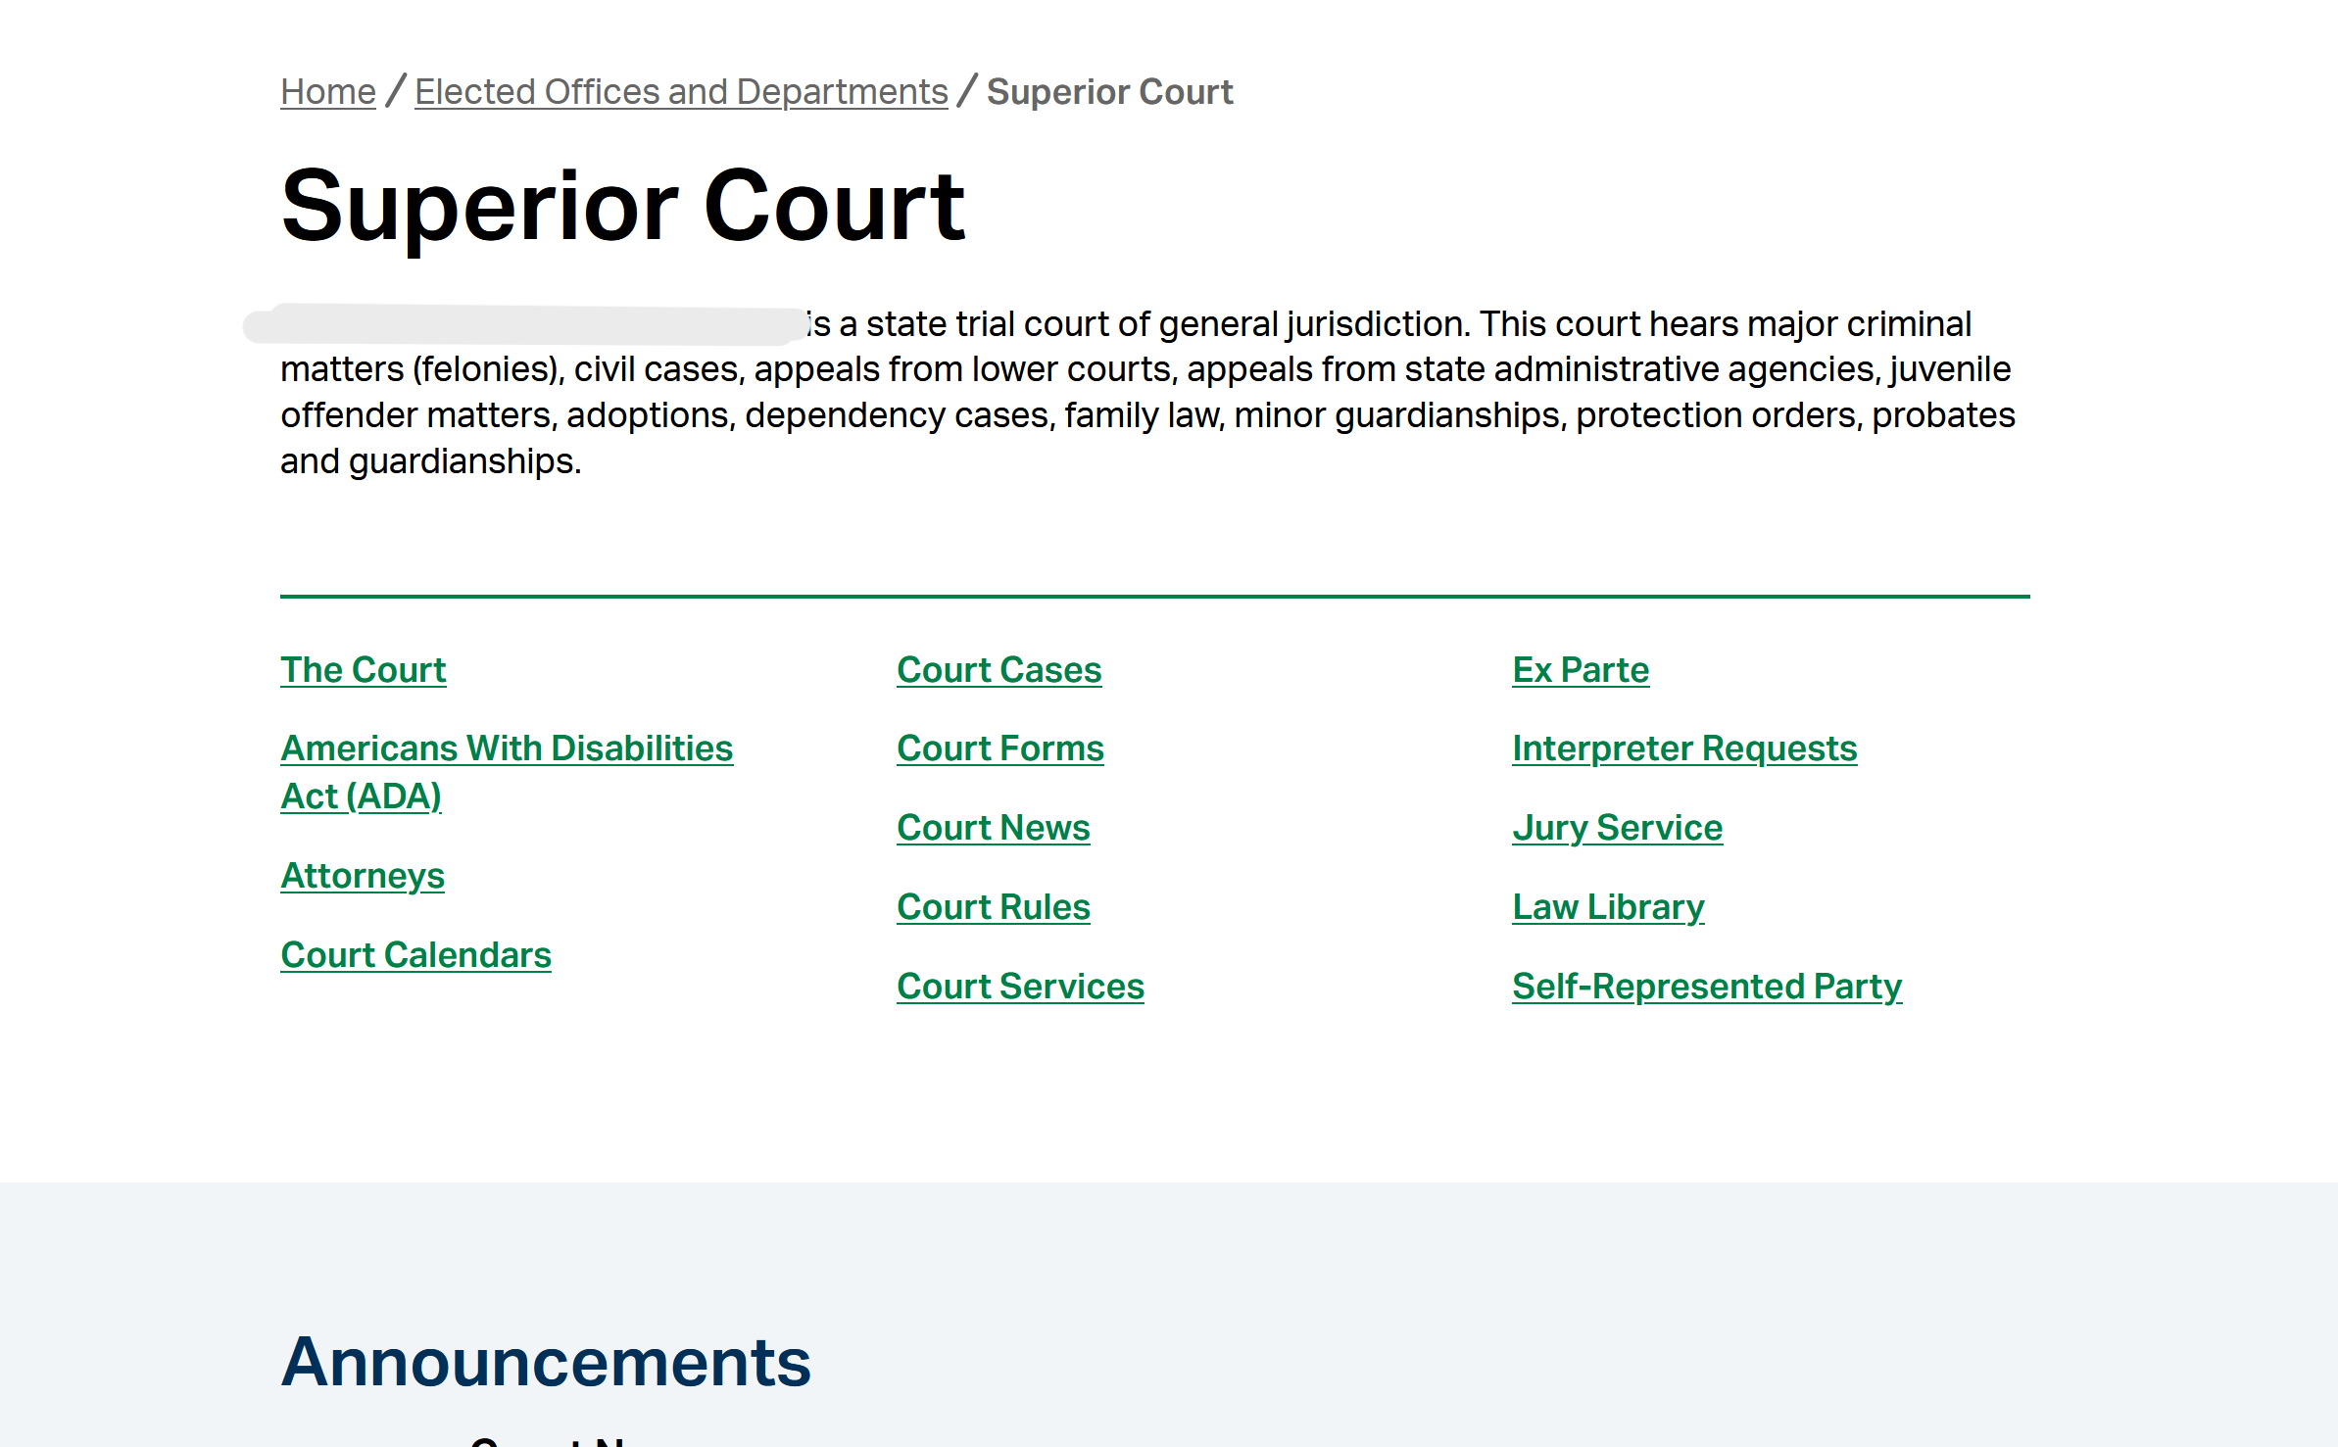

When users navigate to these ADA information pages, the content is structured with frequently asked questions, fillable forms, clear headings, and hyperlinks to related resources. Figure 2 below provides an example of this type of organizational structure. These courts also frequently include information about the grievance procedures, offering transparency about the next steps if an accommodation request is denied.

Figure 2. Superior court ADA information page organized with frequently asked questions displayed in dropdown menus and links to accommodation request forms and grievance procedures.

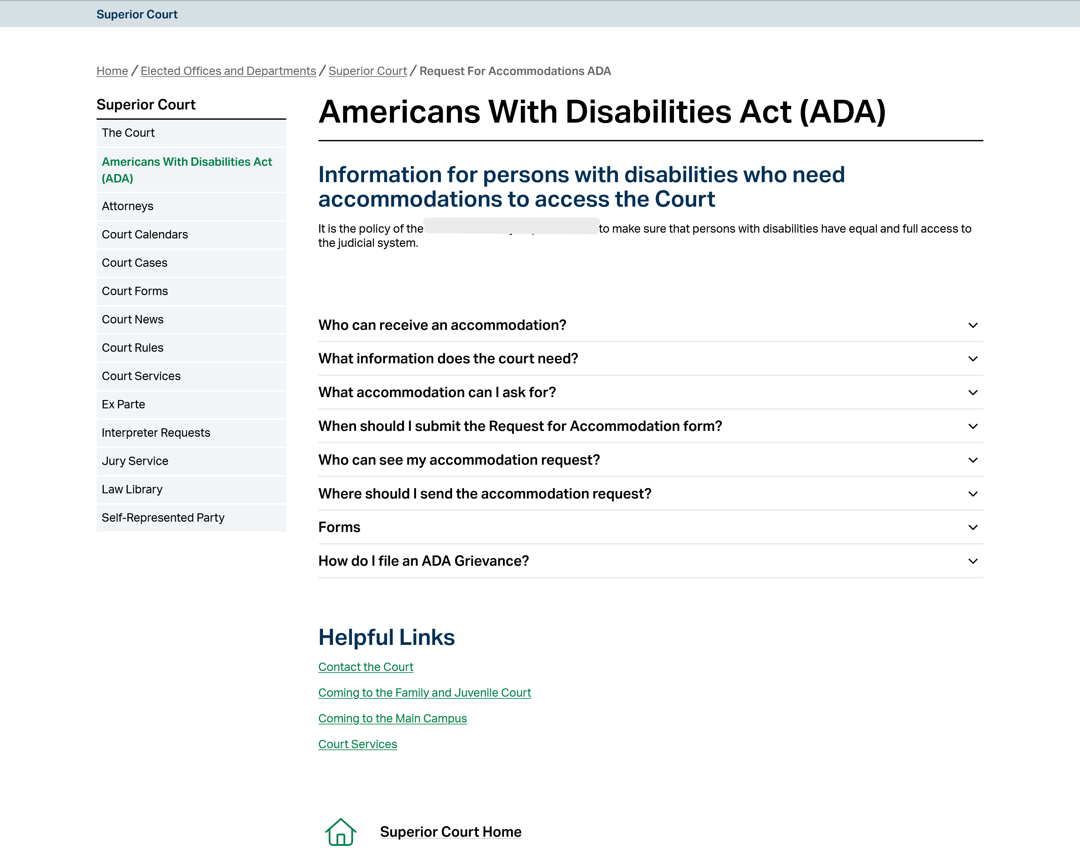

One court further improves usability by providing forms and information about ADA accommodations in both English and Spanish, promoting multilingual access (see Figure 3).

Figure 3. District court website offering ADA accommodation forms and information in both English and Spanish.

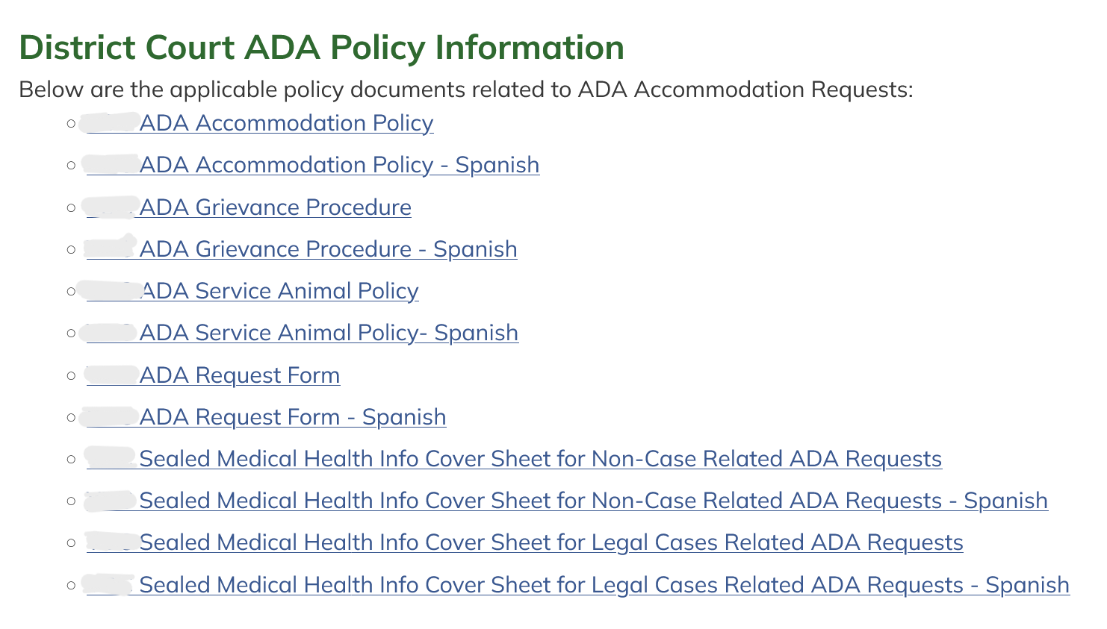

Some courts demonstrate partial compliance with best practices, offering clear forms and examples of available accommodations by omitting key information such as the grievance procedure (see Figure 4).

Figure 4. Superior court website providing detailed information about the accommodation process but lacking any reference to a grievance procedure.
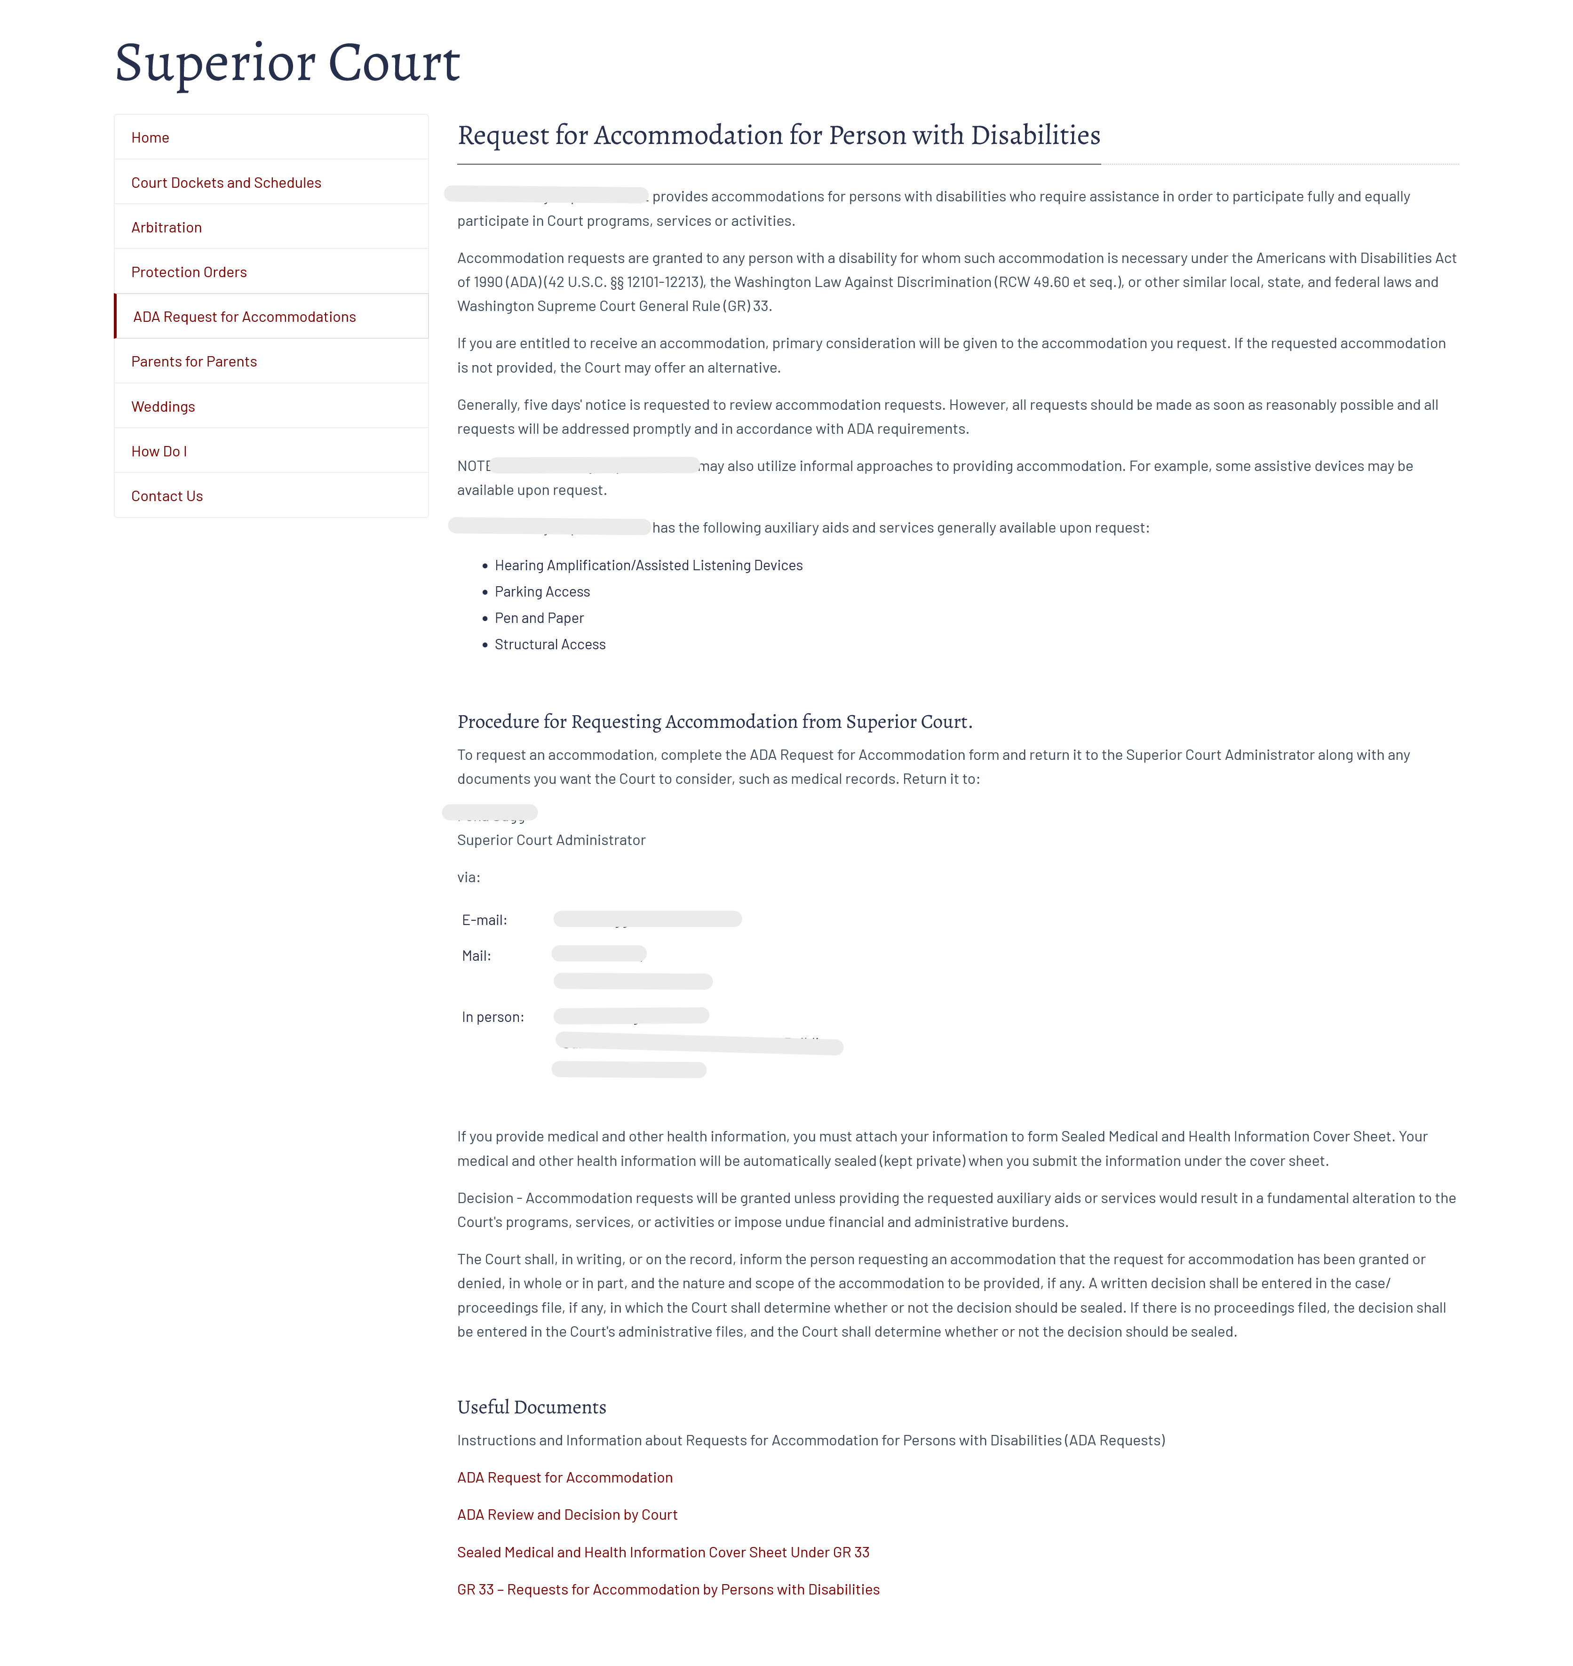

Examples of Areas for Improvement
The majority of court websites in Washington fall short in providing accessible or complete ADA accommodation information. Many link only to a generic GR 33 form without instructions, contact information, or explanations of the process. Others include broken hyperlinks, outdated documents, or no ADA-related content at all. In some cases, the website design itself presents barriers such as low-contrast color combinations that limit site readability. For example, several courts provide accommodation request links that either redirect users away from the court’s site, lead to inactive pages, or appear in areas of the webpage that are difficult to locate (see Figures 5 - 8).

Figure 5. Superior court homepage with a “Request for Reasonable Accommodations for Persons with Disabilities” hyperlink located under “Quick Links” at the bottom of the webpage.
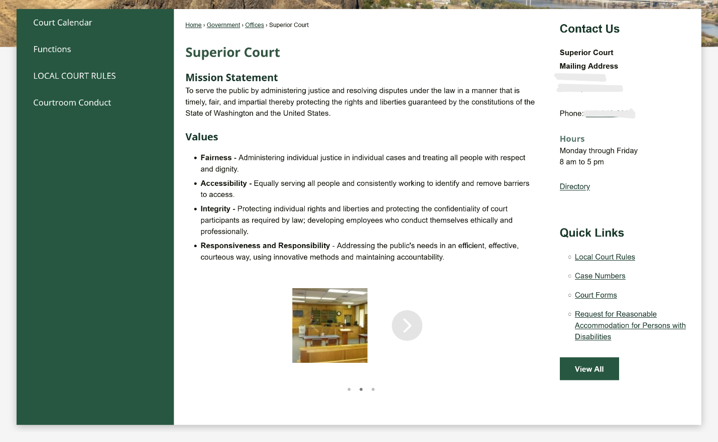

Figure 6. Timed pop-up message appearing on a superior court website that states, “You are now leaving our website,” with a five-second countdown before redirecting users.
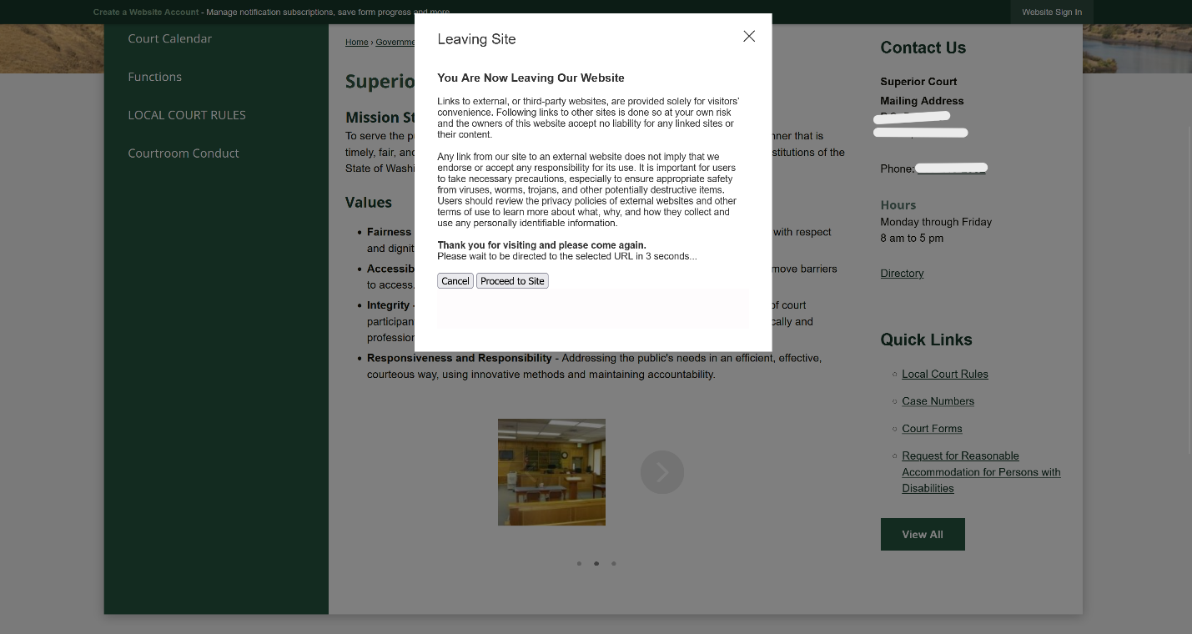

Figure 7. Municipal court website showing a “GR 33 Request for Accommodation” link listed under “Common Resources”.
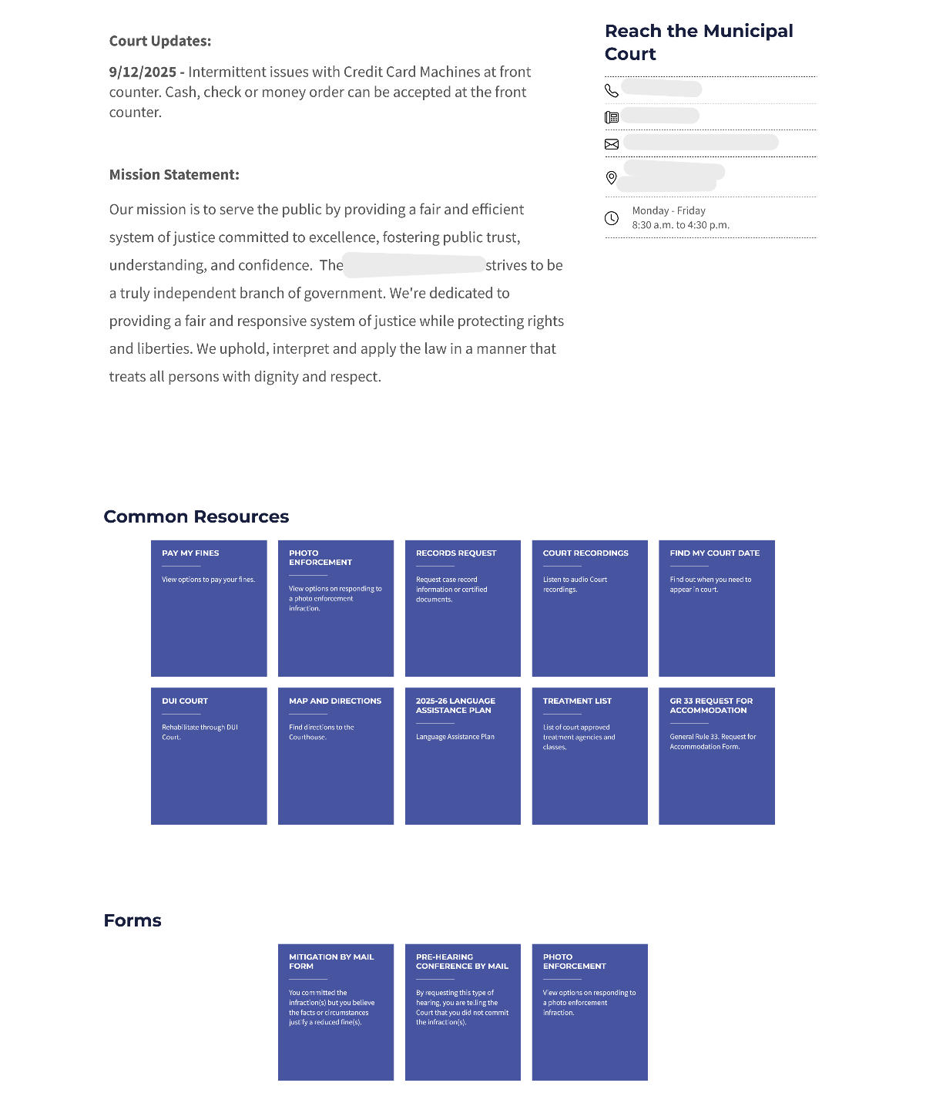

Figure 8. Error page message reading “Sorry, this site/page is currently unavailable,” which appears when users click on the ADA accommodation link from a municipal court website.
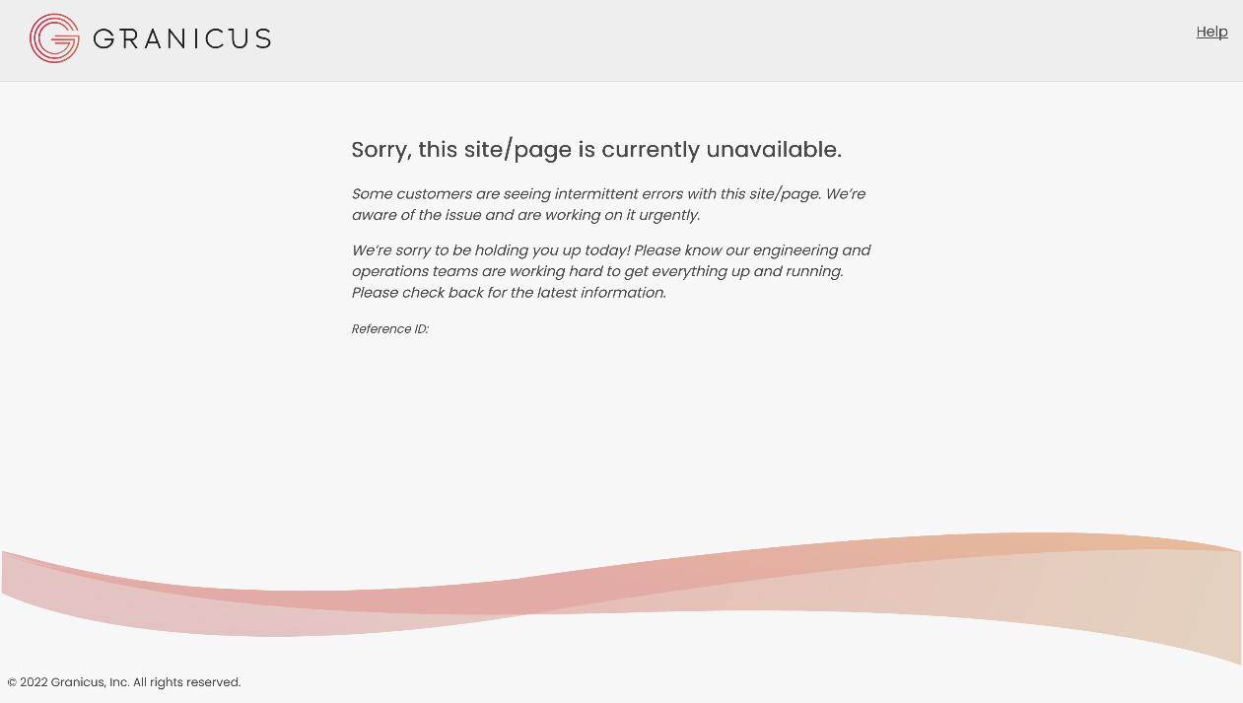

One district court prominently displays a mission statement emphasizing “equal access to justice for all,” yet offers no ADA accommodation information on its website (see Figure 9).

Figure 9. District court website displaying a mission statement emphasizing “equal access to justice for all,” yet offering no ADA accommodation information or forms.
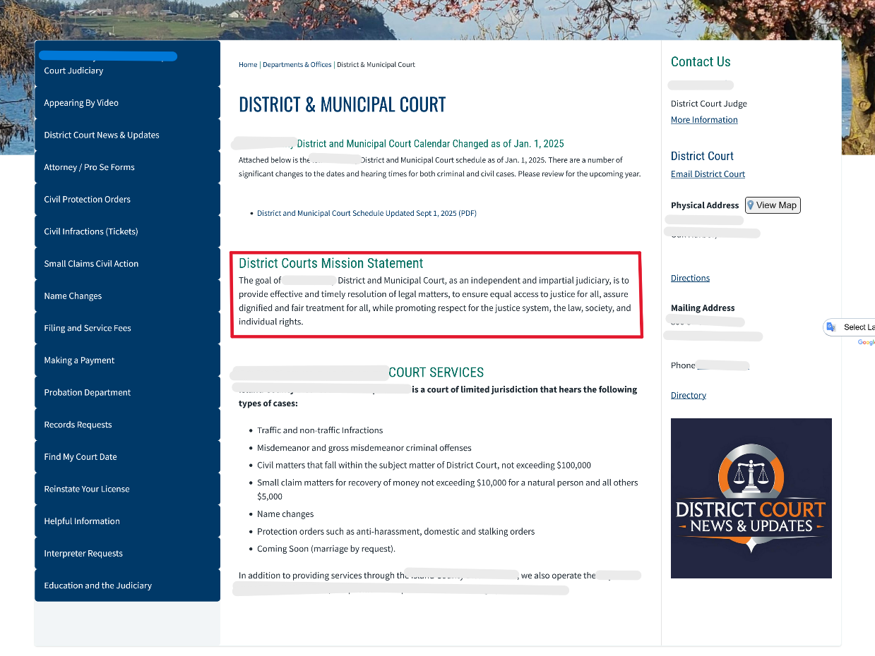

Figure 10 below is an example of a page rendered nearly unreadable due to poor selection of contrast. The municipal court’s website below presents bright yellow headers on a white background, significantly reducing readability (see Figure 10).

Figure 10. Municipal court website featuring bright yellow headers on a white background, reducing text readability and visual contrast.
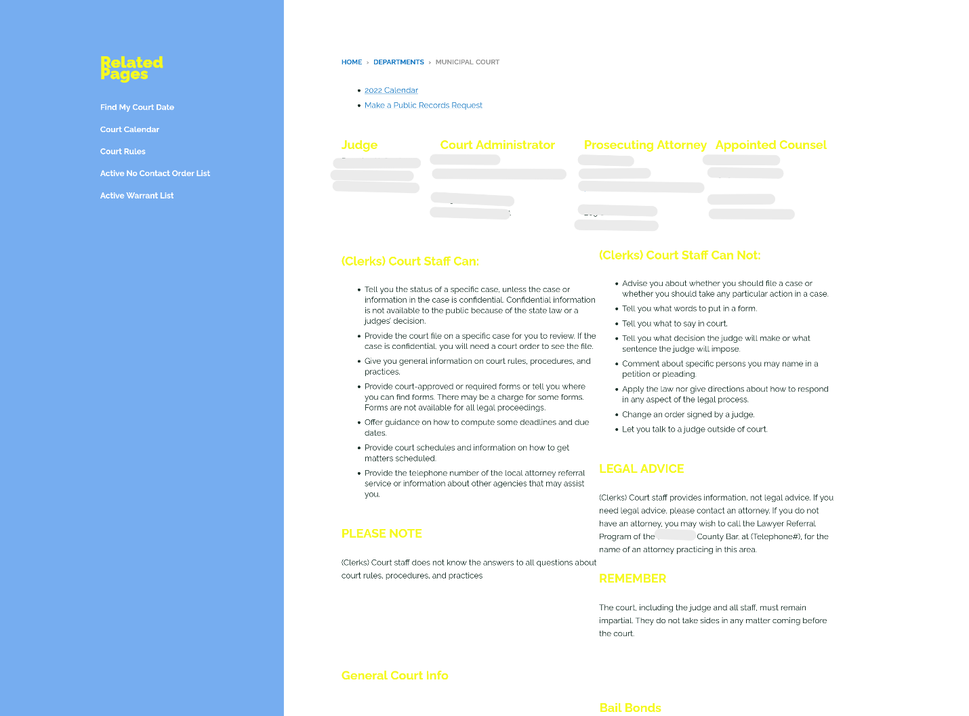

Study Limitations
Several limitations should be considered when interpreting the findings of this study. The analysis was limited to publicly available websites as of February through May 2025, providing a ‘snapshot’ in time and may not reflect ongoing updates or improvements. Some courts are actively updating their websites or digital systems in response to recent DOJ rulings on accessibility, meaning findings may not fully capture current compliance. In addition, our review did not include other potential channels of communication, such as phone inquiries, in-person requests, or email correspondence. As a result, the study may underestimate the extent to which courts provide information about ADA accommodations through non-digital means.
This study did not assess the accessibility of websites or documents according to WCAG 2.1 Level AA standards. While the presence of ADA information was coded, the usability or accessibility of that content for individuals with disabilities was not systematically evaluated. Therefore, even courts with ADA information posted may still present barriers to access.
Finally, while the study focused on website content for municipal, district, and superior trial courts, appellate courts were not included, and findings may not generalize to these or other judicial entities. Similarly, smaller municipal courts that share websites or refer users to neighboring courts were excluded, which could influence overall statewide compliance estimations. Despite these limitations, the study provides valuable insight into the accessibility of ADA accommodation information on Washington State court websites and identifies clear gaps in notice and instructions that may hinder access to justice for individuals with disabilities.

References
Brault, M., Harrison, O., Gips, K., Angel, J., & Blakeslee, K. (2019). Results from the Identifying Challenges to Implementing the ADA Survey for Cities and Towns in New England. Institute for Human Centered Design.
Eisenberg, Y., Heider, A., Gould, R., & Jones, R. (2020). Are communities in the United States planning for pedestrians with disabilities? Findings from a systematic evaluation of local government barrier removal plans. Cities, 102.
New Rule 33 – Requests for Accommodation by Persons with Disabilities. Submitted by the Washington State Access to Justice Board and the Washington State Bar Association (2007). Available online at: https://www.courts.wa.gov/court_rules/?fa=court_rules.proposedRuleDisplay&ruleId=92
Oregon Judicial Department. (2006). Task Force on Access to State Courts for Persons with Disabilities Report. Retrieved February 24, 2024 from https://www.osbar.org/_docs/resources/06DTF_Report.pdf.
Parkin, Michael and Justin Wedeking. (January–March 2017). “Connecting with the Courts.” The Justice System Journal, Vol. 38, No. 1 :22-36.
U.S. Access Board, Courthouse Access Advisory Committee. (Nov 15 2006). Justice for All: Designing Accessible Courthouses. Retrieved February 26, 2025 from https://www.access-board.gov/files/advisory-committee-reports/caac-report.pdf.
U.S. Department of Justice, Civil Rights Division. (n.d.). ADA Best Practices Tool Kit for State and Local Governments: Chapter 2 – ADA Coordinator, Notice & Grievance Procedure. ADA.gov. Retrieved February 26, 2025, from https://archive.ada.gov/pcatoolkit/chap2toolkit.htm
U.S. Department of Justice, Civil Rights Division, Fact Sheet: New Rule on the Accessibility of Web Content and Mobile Apps Provided by State and Local Governments (Apr. 8, 2024), https://www.ada.gov/resources/2024-03-08-web-rule/
U.S. Department of Justice, Civil Rights Division. (n.d.). 28 CFR Part 35 Nondiscrimination on the Basis of Disability; Accessibility of Web Information and Services of State and Local Government Entities (effective June 23, 2024), CRT Docket No. 144; AG Order No. 5919-2024; RIN 1190-AA79 Retrieved February 26, 2025, from: https://www.ada.gov/assets/pdfs/web-rule.pdf.
U.S. Department of Justice, State and Local Governments: First Steps Toward Complying with the Americans with Disabilities Act Title II Web and Mobile Application Accessibility Rule (Jan. 8, 2025), https://www.ada.gov/resources/web-rule-first-steps/
U.S. Department of Justice, Civil Rights Division. (n.d.). Project Civic Access. ADA.gov. Retrieved February 26, 2025, from https://archive.ada.gov/civicac.htm
Tennessee v. Lane, 541 U.S. 509 (2004).
Washington State Access to Justice Board Impediments Committee. (2006). Ensuring Equal Access for People with Disabilities: A Guide for Washington Courts, Revised 2011 (online only).” (2006). Available online at: https://www.courts.wa.gov/content/publicUpload/Access%20to%20Justice%20Committee/AGuideforWashingtonCourtsupdated2011.pdf
Washington State Administrative Office of the Courts. (2025). Self-Help: American Disabilities Act (ADA). Retrieved from https://www.courts.wa.gov/self-help/ada/
Washington State Supreme Court Disability Justice Task Force. Washington State Courts. Retrieved February 26, 2025, from https://www.courts.wa.gov/disability-justice-task-force/
Washington State Supreme Court, Disability Justice Task Force. (2025). Disability Justice Study. Retrieved September 25, 2025 from https://www.courts.wa.gov/disability-justice-task-force/public/FINAL-DJTF-STUDY-REPORT.pdf.
Washington State Courts. (n.d.). General Rule 33: Requests for Accommodation by Persons with Disabilities. Retrieved February 26, 2025, from https://www.courts.wa.gov/court_rules/pdf/GR/GA_GR_33_00_00.pdf
Washington State Courts. (n.d.). Court Forms: General Rule 33 Request for Reasonable Accommodation. https://www.courts.wa.gov/forms/?fa=forms.contribute&formID=71
Web Content Accessibility Guidelines (WCAG) 2.1 (n.d.) World Wide Web Consortium. Available at: https://www.w3.org/TR/WCAG21/.
W3C Recommendation. (May 6, 2025). Web Content Accessibility Guidelines (WCAG) 2.1 (n.d.) World Wide Web Consortium. Available at: https://www.w3.org/standards/types/#REC.
Wentz, Brian, Sparsh Paliwal, Ursula Gorham, Paul Jaeger & Jonathan Lazar. (2024). “Inaccessible PDF Forms Limited Access to the Courts during the Pandemic: A Window into Broader Issues of Inequities and Inaccessibility for People with Disabilities in the United States,” Including Disability 4:1-24, https://doi.org/10.51357/id.v4i.262.

Wash. Gen. R. 33, Requests for Accommodation by Persons with Disabilities (adopted Sept. 1, 2007; amended Dec. 28, 2010; Sept. 1, 2014; Jan. 1, 2023), https://www.courts.wa.gov/court_rules/pdf/GR/GA_GR_33_00_00.pdf
Brault et al. 2019; Eisenberg et al. 2020; see also U.S. Department of Justice, Civil Rights Division’s Project Civic Access for a list of settlement agreements between the DOJ and local or state governments in Furthering compliance with the ADA.
The ADA requires state and local government agencies, like courts, to make “reasonable modifications” or changes to policies, procedures and practices when necessary to allow disabled people access. A common example of a reasonable modification is a “change” to a no-pets policy in order to allow access to people who use service animals. Another positive right under the ADA is the right to effective communication. Under the ADA, people with communication disabilities have a right to communication with state and local agencies that is as effective as communication for non-disabled people. Effective communication is primarily ensured by providing “auxiliary aids and services” which include American Sign Language interpreters, materials in large print or braille, or captioning. Finally, the ADA mandates that public agencies, like courts, ensure that inaccessible buildings do not pose a barrier to accessing government services. This requirement is referred to as “program access,” and courts can meet this requirement by removing barriers (by making structural alterations) or by changing the location where services are provided. For example, in a building without an elevator, a court could move a hearing from the second to the first floor to ensure access.
Under the ADA, the term “reasonable accommodations” refers specifically to accommodations made in the employment context. However, in practice, it is common to use the term “reasonable accommodation” to refer to modifications to policies or procedures as well as the provision of auxiliary aids and services, like sign language interpreters. In addition, as discussed later, GR 33 defines accommodation to include reasonable modifications, auxiliary aids and services, as well as other “measures to make each court service, program, or activity, when viewed in its entirety, readily accessible to and usable by a person with a disability.”
U.S. DOJ Civil Rights Division Best Practices Toolkit for State and Local Governments, Chapter 2, B(2).
The notice must be available in alternate formats, such as braille and large print (Id.).
See 28 CFR Part 35 Nondiscrimination on the Basis of Disability; Accessibility of Web Information and Services of State and Local Government Entities.
28 CFR § 35.106 Notice. A public entity shall make available to applicants, participants, beneficiaries, and other interested persons information regarding the provisions of this part and its applicability to the services, programs, or activities of the public entity, and make such information available to them in such manner as the head of the entity finds necessary to apprise such persons of the protections against discrimination assured them by the Act and this part.
In 2004, the U.S. Access Board organized a Courthouse Access Advisory Committee to develop technical guidance for designing accessible courthouses. The Advisory Committee’s 2006 Recommendations explain how to apply the ADA and the ABA (Architectural Barriers Act) Standards to features specific to a courthouse, such as a raised jury box. In 2004, the National Center for State Courts issued a compilation of Department of Justice enforcement activities related to state and local courts from 1994-2004 (“Enforcement Activities Under the Americans with Disabilities Act Title II: Programs, Services and Activities of State and Local Courts,” National Center for State Courts, June 2004). The purpose of the report was to create a guide to help state and local courts meet ADA requirements. In 2006, the Oregon Judicial Department and the Oregon Bar Association issued a report on Access to State Courts for Persons with Disabilities.
The guide was updated in 2011. Available online at: https://www.courts.wa.gov/content/publicUpload/Access%20to%20Justice%20Committee/AGuideforWashingtonCourtsupdated2011.pdf
In 2004, the United States Supreme Court made the following observations in upholding application of the ADA to courts and court services: The unequal treatment of disabled persons in the administration of judicial services has a long history, and has persisted despite several legislative efforts to remedy the problem....Faced with considerable evidence of the shortcomings of previous legislative responses, Congress was justified in concluding that this ‗difficult and intractable problem‘ warranted [the enactment of Title II]…. Recognizing that failure to accommodate persons with disabilities will often have the same practical effect as outright exclusion, Congress required the States to take reasonable measures to remove architectural and other barriers to accessibility…. [A]s it applies to the class of cases implicating the fundamental right of access to the courts, [Title II] constitutes a valid exercise of Congress‘…authority to enforce the guarantees of the Fourteenth Amendment. Tennessee v. Lane, 124 S. Ct. 1978, 1993-4 (2004).
However, GR 33 also encourages courts to utilize parallel informal procedures and allows local procedures that are consistent with the purpose of the rule.
The form is available online at https://www.courts.wa.gov/forms/?fa=forms.contribute&formID=71
If the request is presented orally, it must be reduced to writing. GR 33 (b)(4)
Available online at https://www.courts.wa.gov/forms/?fa=forms.contribute&formID=71
However, GR 33 specifically notes that courts should not be “limited” by the ADA’s provisions nor by the provisions of the Washington State Law Against Discrimination. This suggests that courts may provide accommodations that are not required by the ADA or WLAD. GR 33 (c)(1)(A)
New Rule 33 – Requests for Accommodation by Persons with Disabilities. Submitted by the Washington State Access to Justice Board and the Washington State Bar Association (2007). Available online at: https://www.courts.wa.gov/court_rules/?fa=court_rules.proposedRuleDisplay&ruleId=92
For a comprehensive look at the information provided on court websites see Parkin & Wedeking, 2017.
Municipal courts excluded due to lack of an active website: Wilkeson, Noth Bonneville, Cle Elum, Grand Coulee, Roslyn, Raymond, Bridgeport.
New Rule on the Accessibility of Web Content and Mobile Apps Provided by State and Local Governments, available at: https://www.ada.gov/resources/2024-03-08-web-rule/.
Web Content Accessibility Guidelines (WCAG) 2.1, Level AA standards, available at https://www.w3.org/TR/WCAG21/.
State or local governments with a population of 50,000 or more persons have a compliance deadline of April 24, 2026. Only state or local governments with a population of 0 to 49,999 persons have a later compliance date of April 26, 2027. More information about the rule available online at: https://www.ada.gov/resources/web-rule-first-steps/
New Rule 33 – Requests for Accommodation by Persons with Disabilities. Submitted by the Washington State Access to Justice Board and the Washington State Bar Association (2007). Available online at: https://www.courts.wa.gov/court_rules/?fa=court_rules.proposedRuleDisplay&ruleId=92
The study’s authors reviewed seven court website audits previously conducted by the AOC and completed their own audit of one state court website. See Chapter 4: Web Accessibility Audit, p. 248. Disability Justice Study, 2025.
Available online at: https://www.courts.wa.gov/forms/?fa=forms.contribute&formID=71
Washington State Access to Justice Board Justice Without Barriers Committee, Ensuring Equal Access for People with Disabilities: A Guide for Washington Administrative Proceedings (Seattle: Washington State Bar Association Administrative Law Section, May 2011), https://www.wsba.org/docs/default-source/legal-community/sections/adm/resources/adm_resources_access_guide_for_wa_administrative_proceedings_2011.pdf
This recommendation aligns with one of the stated purposes of GR 33: “The suggested rule is further intended to accelerate the development of a comprehensive access management system to assure a clear, consistent, and effective approach to providing appropriate accommodations in Washington courts.” https://www.courts.wa.gov/court_rules/?fa=court_rules.proposedRuleDisplay&ruleId=92
Public entities with 50 or more employees are required to designate at least one employee to coordinate ADA activities. 28 CFR 35.107
Washington State Administrative Office of the Courts, 2025. Available at: https://www.courts.wa.gov/self-help/ada/
Web content accessibility guidelines (WCAG) 2.1 (n.d.) W3C. Available at: https://www.w3.org/TR/WCAG21/.
Washington State Supreme Court Disability Justice Task Force, Disability Justice Study 2025 (Olympia, WA: Washington State Administrative Office of the Courts, 2025), pdf.
Wentz et al., 2024.
Id.

